**Statement of Work**

**Lucid Motors MPB EOL Production Test**

# Revision History

|  |  |  |  |
| --- | --- | --- | --- |
| **Date** | **Version** | **Author** | **Comment** |
| 5/21/2020 | 1.0 | Victor Yang | First draft |
| 5/26/2020 | 1.1 | Mingkai Mu, Kayla Shi, Victor Yang | Add HVIL |
| 5/30/2020 | 1.2 | Shan Chai | Add EOL sequence. |
| 6/10/2020 | 1.3 | Kayla Shi, Victor Yang | Remove Hipot, and add equipment model |
| 7/02/2020 | 1.4 | Mingkai Mu, Victor Yang | Remove 18kW Load and add Compressor |
| 7/06/2020 | 1.5 | Ryan Lembitz | Change Chiller and Pressure |
| 09/17/2020 | 1.6 | Shan Chai/Shan Gao | Diagram, Communication |
| 09/22/2020 | 1.7 | Ryan Lembitz | Change DMM and Hipot brand |
| 09/23/2020 | 1.8 | Shan Gao/Victor Yang | Changed the SOW diagram |
| 09/28/2020 | 1.9 | Eric Kuntzelman | Change the NI relay module to a customized relay module with economizer |
| 09/29/2020 | 1.10 | Eric Kuntzelman/Shan Gao | Change the index number of contactor |

**Purpose**

Lucid Motors is developing and integration plan for MPB (Multifunction Power Box) production test stations. MPB will provide on-board battery charger and DC/DC power function to all electrical vehicle required power following proposal. The Lucid team wants to use LabVIEW software to control all MPB function.

**Test Station Summary**

|  |  |  |
| --- | --- | --- |
| **HV component** | **Assembly level** | **Test station** |
| MPB HVIL | Assembly | HVIL Test |
| MPB Offset Tuning | Assembly | AC charging |
| MPB, AC power source, Electronic Load | Assembly | AC charging |
| MPB, 400V DC power source, Electronic load | Assembly | 400V DC charging |
| MPB, 800V DC power source, Electronic load | Assembly | 800V DC charging Power Line Conductivity |
| MPB, 1000V Power supply, Electronic load | Assembly | HAPS (Heater & AC Compressor) |
| MPB, 1000V Power supply, Electronic load | Assembly | DCDC |

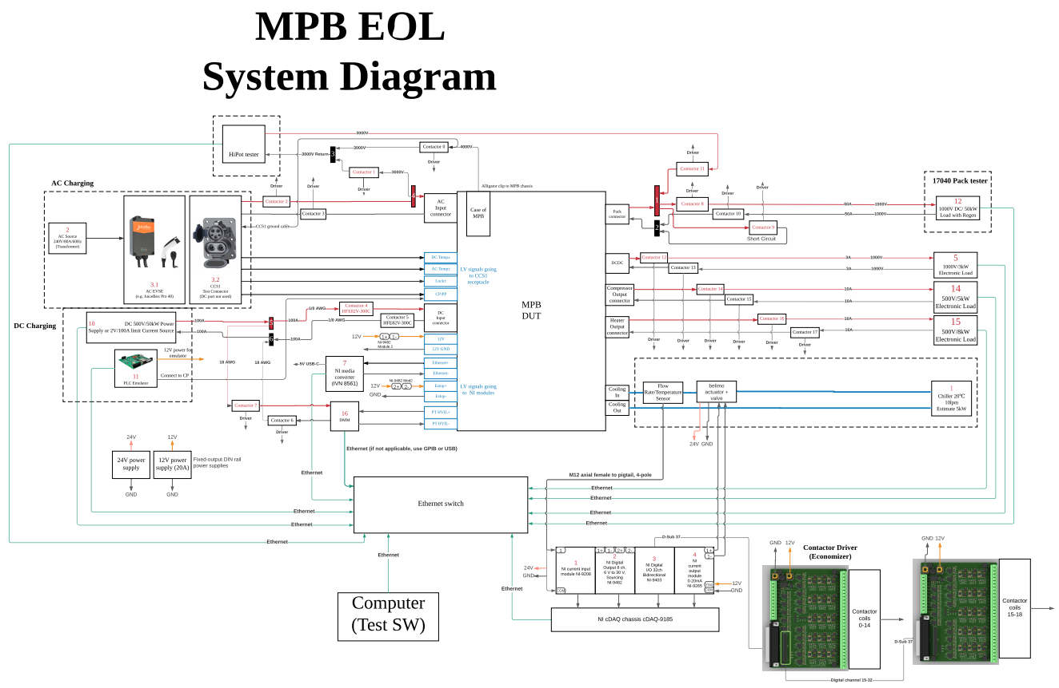

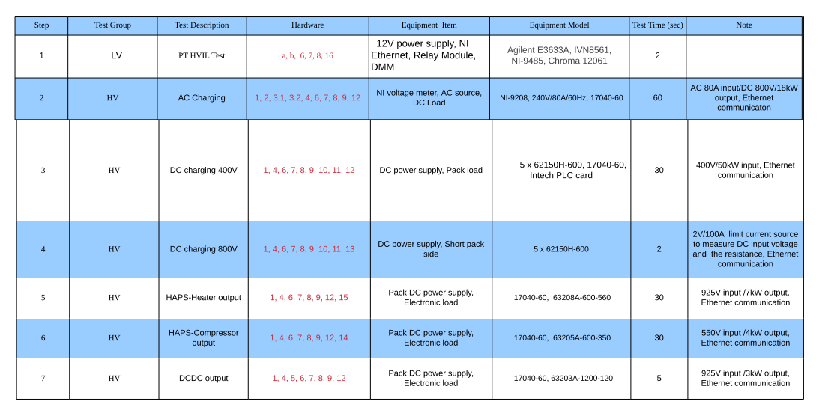

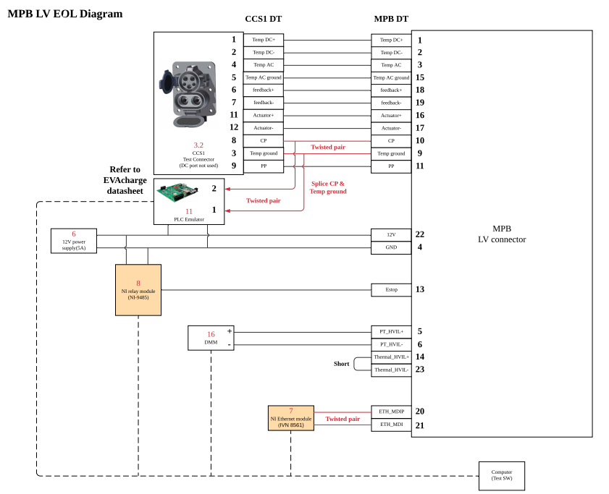

GXV600M

<https://www.gigavac.com/sites/default/files/catalog/spec_sheet/GXV600_DATASHEET_REV_3.pdf>

ACS will need to control 4, 5, 6, 7, 8, 9, 10, 12, 14, 15.

|  |  |  |
| --- | --- | --- |
| Equipment No. | Model | Link |
| 4 | 2X E3633A, Agilent  12V Power supply, 4X contactor | <http://literature.cdn.keysight.com/litweb/pdf/E3634-90001.pdf>  <http://en.hf-relay.com/uploadfile/2019/0507/20190507032909220.pdf> |
| 5 | 1000V/3kw DCDC Load  Chroma  62150H-600 | <http://www.chromaate.com/chroma/webdrive/catalogue/APP/TestMeasurement-PQG-E.pdf> |
| 6 | E3633A, Agilent  12V Power supply | <http://literature.cdn.keysight.com/litweb/pdf/E3634-90001.pdf> |
| 7 | NI Ethernet Module  IVN 8561 | Need to confirm if this is controlled via DSA.  <https://www.ni.com/en-us/support/model.ivn-8561.html> |
| 8 | NI relay model  NI-9485 | <https://www.ni.com/pdf/manuals/374820a_02.pdf> |
| 9 | Ni Voltage Module  NI 9208 | <https://www.ni.com/en-us/support/model.ni-9208.html> |
| 10 | DC500V/50Kw  Power Supply  Chroma 62150H-600 | <https://www.chromausa.com/pdf/62000H%20Datasheet.pdf> |
| 11 | DMM, Chroma 12061 | <https://www.chromausa.com/product/digital-multimeter-12061/?gclid=EAIaIQobChMIzKzbqai-6gIVUhh9Ch1nBwpJEAAYASAAEgI62_D_BwE> |
| 12 | Regenerative Battery pack, Chroma 17040 | <http://www.chromausa.com/pdf/17040-Regenerative%20Battery%20Pack-0519.pdf> |
| 14 | AC compressor  Electric Load  Chroma  63205A-600-350 | [www.chromaate.com/chroma/webdrive/catalogue/APP/TestMeasurement-PQG-E.pdf](http://www.chromaate.com/chroma/webdrive/catalogue/APP/TestMeasurement-PQG-E.pdf) |
| 15 | Heater Electric Load  Chroma  63208A-600-560 | [www.chromaate.com/chroma/webdrive/catalogue/APP/TestMeasurement-PQG-E.pdf](http://www.chromaate.com/chroma/webdrive/catalogue/APP/TestMeasurement-PQG-E.pdf) |
| 16 | Chroma  19053  Hipot Tester | <https://www.tequipment.net/Chroma/19053/Hipot-Tester/?gclid=EAIaIQobChMIkInouMP96wIV6xatBh3OigaHEAAYASAAEgIHS_D_BwE> |

In the EOL tests proposed below, it is required that LabVIEW will send a sequence number to MPB to setup the test mode for the corresponding test. Table below summaries communication that shall happen between LabVIEW and MPB.

Table 1: Ethernet Communication definition between MPB and LabVIEW

|  |  |
| --- | --- |
| Sequence Number | Used in Test |
| 1 | Close Relays of MPB in HiPot AC Test |
| 2 | Close Contactors of MPB in HiPot Batt-case Test |
| 3 | HIPOT Turn off All contactors |
| 4 | HVIL Test |
| 5 | Start- Offset Tuning |
| 6 | Read Offsets – Offset Tuning |
| 7 | AC Charge |
| 8 | DC 400V |
| 9 | DC 800V |
| 10 | HAPS-Heater output |
| 10 | HAPS-Compressor output |

Communication Protocol Automotive Ethernet:

MPB IP Address: 192.168.1.9

MPB VLAN: 1

MPB PORT: 11111

PC IP Address: 192.168.1.123

PC VLAN: 1

PC Port : 11112

Labview Sending Data Format :

|  |
| --- |
| 0 |
| SeqId |

Labview Receving Data Format: (Data size depends on Payload size)

|  |  |  |  |
| --- | --- | --- | --- |
| 0 | 1 | 2 |  |
| SeqId | Payload Size | Data |  |

Integration Proposal

Application Flashing

1. LabVIEW shall turn on the 12V power supply.
2. LabVIEW shall send signal to DSA to achieve software flashing via UDS.

Hipot Test

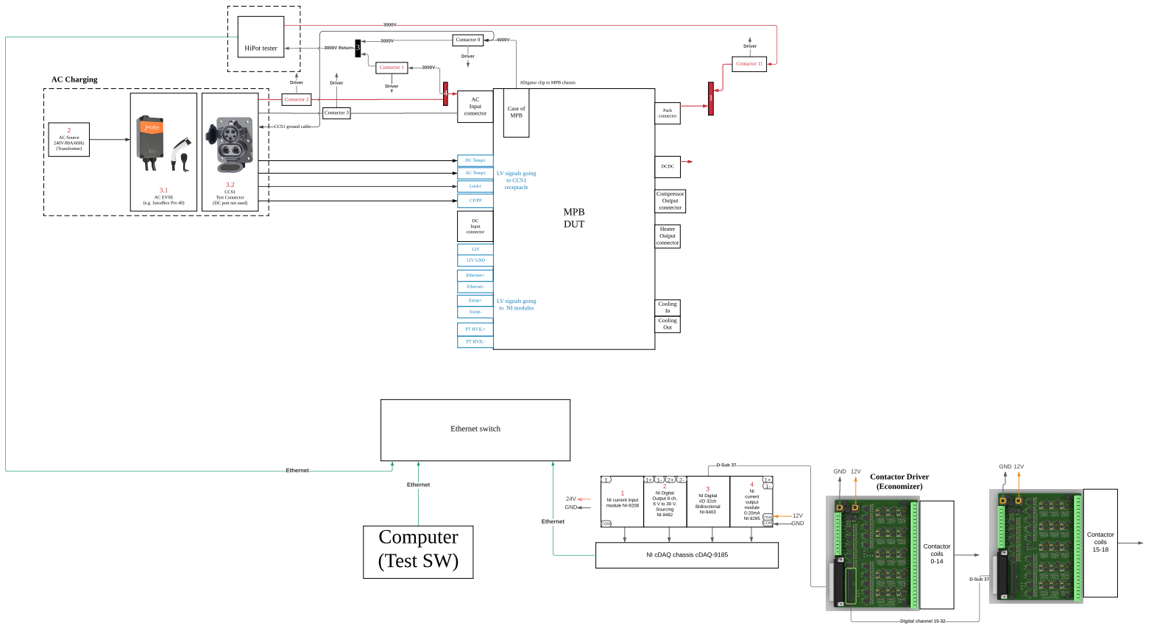

HIPOT AC TEST

1. Connect Chroma 19053 Hipot tester output to AC input
2. Connect Hipot tester input to Pack connector
3. LABVIEW shall sent out sequence number 1 to MPB to close the AC relays in MPB.
4. Send out signal to turn on Hipot tester.
   1. Test setting (3000V, 10s Ramping, 30s holding, current<2mA)
   2. IR resistor should be above 10M
5. Record Pass/Fail

HIPOT Battery-Case Test

1. Connect Chroma 19053 Hipot tester output to MPB case
2. LabVIEW shall send out signal to MPB sequence number 2 to close the internal contactors and relays.
3. Send out signal to turn on Hipot tester
   1. Test setting (3000V, 10s Ramping, 30s holding, current<2mA)
   2. IR resistor should be above 10M
4. Record Pass/Fail
   1. current<2mA)
   2. IR resistor should be above 10M
5. Record Pass/Fail
6. Turn off power
7. LAVIEW shall send out signal to MPB sequence number 3 to disconnect the internal contactors and relays.

MPB Automotive Ethernet Interface

All MPB communication shall be integrated to LabVIEW test program

Test Software

* LabVIEW

Test Data Requirements

|  |  |
| --- | --- |
| Test input |  |

HVIL Test

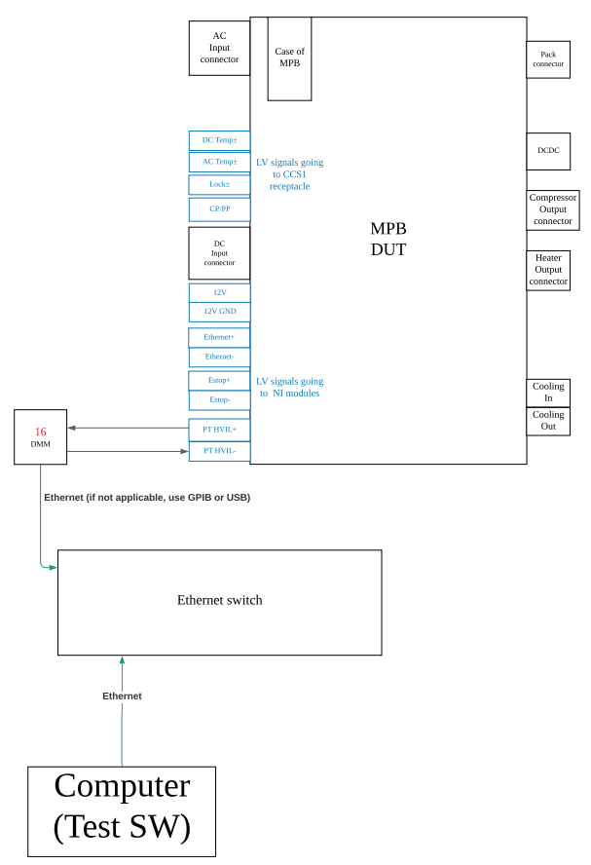

Connection and Test sequence

1. Insert connectors for MPB Inverter output, AC input, DC input, DCDC, and Pack connectors
2. Insert connectors for LV connector, Heater, and Electronic AC compressor connectors
3. Record continuity between pin 5 and pin 6 (PT HVIL) of the LV connector, and use LabVIEW monitor resistance.
4. The LabVIEW shall send the sequence number 4 to start HVIL Tester. MPB will conduct self-test and send the result back to LabVIEW.

**LabVIEW Receiving Data Format:**

|  |  |  |
| --- | --- | --- |
| 0 [SeqId] | 1[Payload Size] | 2[Data] |
| 4 | 1 | 1/0 |

1. The LabVIEW shall display the result.
2. Check Pass/Fail and turn off power

|  |  |
| --- | --- |
| Test output | Pass/Fail |
| Test log | Yes |

MPB Automotive Ethernet Interface

All MPB communication shall be integrated to LabVIEW test program

Test Software

* LabVIEW

Test Data Requirements

|  |  |
| --- | --- |
| Test input |  |
| Test output | Pass/Fail |
| Test log | Yes |

Sensor Offset Tuning and Calibration

*This procedure has to be conducted before any of the following high power test.*

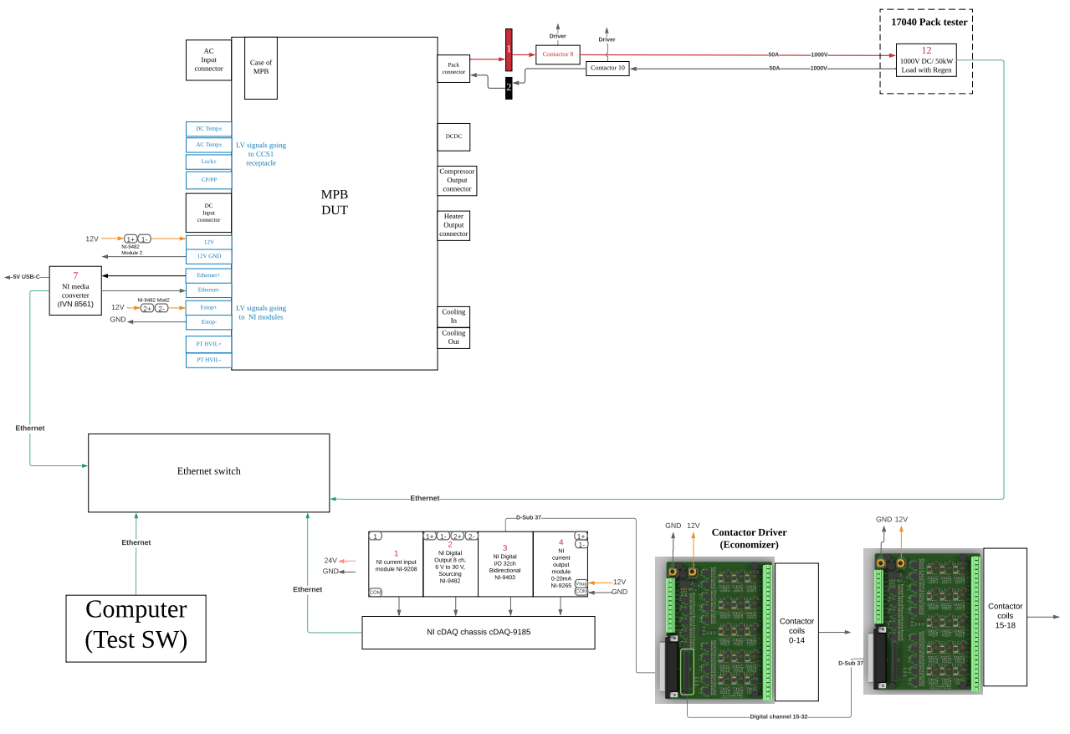

Connection and Test sequence

1. Use LabVIEW to send signal to turn on LV Harness with 12V power supply.
2. Use LabVIEW to send the EOL sequence number 5 to MPB to start the sequence.
3. Use LabVIEW to send the EOL sequence number 6 to MPB to get the offset values.
4. Connect the DC supply to the battery port, through contactors.
5. Use LabVIEW to send the EOL sequence number ??? to get the data
6. Control DC supply to provide 800V to the MPB battery port
7. Use LabVIEW to read the data in MPB, and compare with the reference for pass/fail.
8. Turn off the power supply, wait until the internal voltage go low.
9. Use LabVIEW to send command to disconnect contactors in the MPB.
10. **Labview Receiving Data Format :**

|  |  |  |
| --- | --- | --- |
| 0 [SeqId] | 1[Payload Size] | 2[Data] |
| 4 | 1 | 1/0 |

1. LabVIEW shall display and compare it with pre-defined threshold to indicate it pass or fail.

MPB Automotive Ethernet Interface

All MPB communication shall be integrated to LabVIEW test program

Test Software

* LabVIEW

Test Data Requirements

|  |  |
| --- | --- |
| Test input |  |
| Test output | Pass/Fail |
| Test log | Yes |

AC charging

Connection and Test sequence

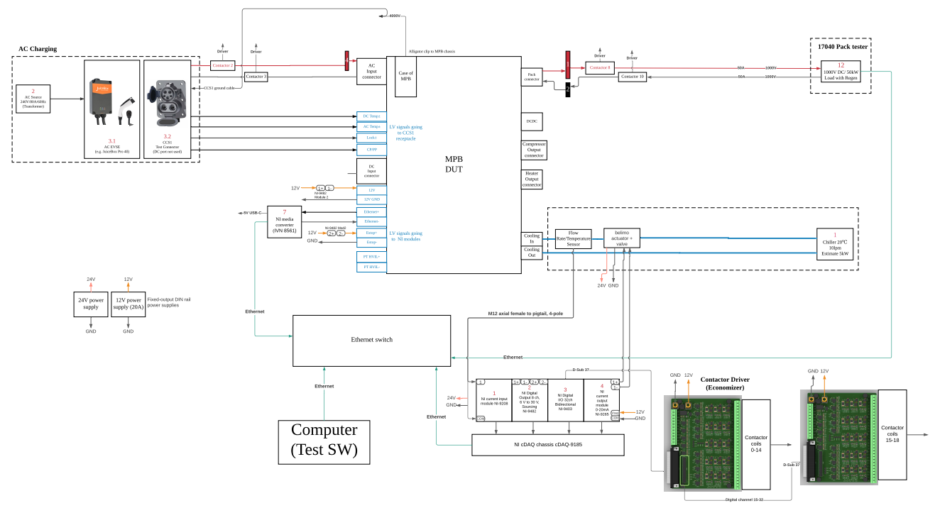

1. Turn on AIR1000 chiller with 20psi and 20C test condition and connect coolant with MPB through water pipe during the test.
2. Set Regenerative Battery Pack (model 17040) to 800V/18kW as an Electronic Load (50Ohm) and connect to MPB Pack connector by switching on the corresponding contactors from LabVIEW.
3. TURN on 925V power supply.
4. Connect AC source to EVSE, and insert charging gun to AC connector
5. Use LabVIEW to send signal to turn on LV Harness with 12V power supply and all NI sensor detectors.
6. Use LabVIEW send Ethernet signal to start the EOL sequence 7 and also send/receiving the following Ethernet Signal

|  |  |  |
| --- | --- | --- |
| AC Charge Test | | |
| Sending Signals | Value | Unit |
| IPT_State | 2 | Enum |
| IBMU_ChrgCurrTar | 19 | A |
| IBMU_ChrgVoltTarg | 924 | V |
| IMPB_FltClear (TBD) | 0 | Bool |
|  |  |  |
| Reading Signals | Value | Unit |
| IMPB_BattCurrDAB1 |  | A |
| IMPB_BattCurrDAB2 |  | A |
| IMPB_BattVoltgHiRes |  | V |
| IMPB_DCbusVoltg |  | V |
| IMPB_BattPortPower |  | was |
| IMPB_HwFltCode |  | uint32 |
| IMPB_SwFltCode (TBD) |  | uint32 |
| IMPB_HwFltFlag |  | Bool |

1. Use LabVIEW to send signal to turn on AC power to start to charge.
2. MPB will send output DC voltage, DC current and fault code to LabVIEW via Ethernet.
3. LabVIEW shall display and compare it with pre-defined threshold to indicate it pass or fail.
4. Check Pass/Fail and turn off power

MPB Automotive Ethernet Interface

All MPB communication shall be integrated to LabVIEW test program

Test Software

* LabVIEW

Test Data Requirements

|  |  |
| --- | --- |
| Test input |  |
| Test output | Pass/Fail |
| Test log | Yes |

DC 400V charging

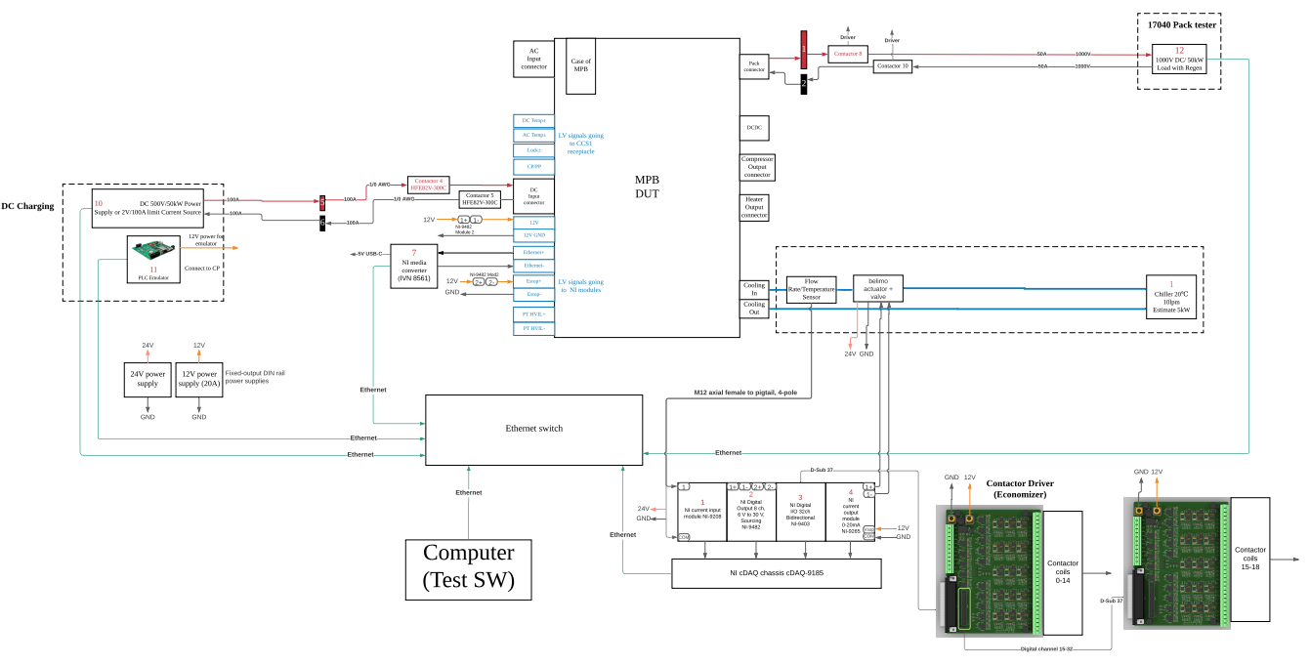

Connection and Test sequence

1. Set Regenerative Battery Pack (model 17040) to 1000V/50kW as an Electronic Load and connect to MPB Pack connector by switching on the corresponding contactors from LabVIEW.
2. Use LabVIEW to send signal to turn on LV Harness with 12V power supply and all NI sensor detectors.
3. Start PLC (Power Line Communication) emulator software on PC.
4. Use LabVIEW to send the EOL sequence number 8 and send/receive the following signal.

|  |  |  |
| --- | --- | --- |
| Sending Signals | Value | Unit |
| IPT_State | 2 | Enum |
| IBMU_ChrgCurrTar | 50 | Bool |
| IBMU_ChrgVoltTarg | 924 | V |
| IMPB_FltClear (TBD) | 0 | Bool |
|  |  |  |
| Reading Signals | Value | Unit |
| IMPB_BattCurrDAB1 |  | A |
| IMPB_BattCurrDAB2 |  | A |
| IMPB_BattVoltgHiRes |  | V |
| IMPB_DCbusVoltg |  | V |
| IMPB_BattPortPower |  | was |
| IMPB_HwFltCode |  | uint32 |
| IMPB_SwFltCode (TBD) |  | uint32 |
| IMPB_HwFltFlag |  | Bool |

1. PLC emulator on PC will turn on 500V/50kW DC power to start to charge.
2. MPB will send output DC voltage, DC current and fault code to LabVIEW via Ethernet.
3. LabVIEW shall display and compare it with pre-defined threshold to indicate it pass or fail.
4. Check Pass/Fail and turn off power

MPB Automotive Ethernet Interface

All MPB communication shall be integrated to LabVIEW test program.

Test Software

* LabVIEW

Test Data Requirements

|  |  |
| --- | --- |
| Test input |  |
| Test output | Pass/Fail |
| Test log | Yes |

DC 800V Charging Power Line Conductivity

*The main purpose of this test is to test the conductivity of 800V power line on MPB instead of 800V charging.*

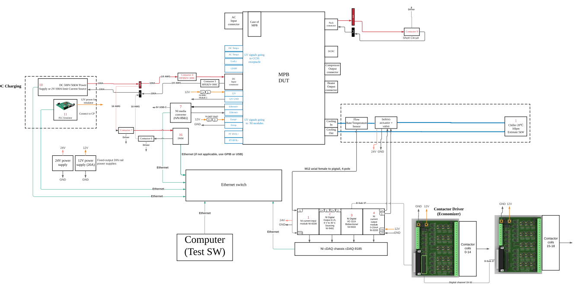Connection and Test sequence

1. Switch to connect MPB Pack connector to short connection by switching on the corresponding contactor from LabVIEW.
2. Use LabVIEW to set 50kW DC power to 2V/100A limit
3. Use LabVIEW to send signal to turn on LV Harness with 12V power supply and NI sensor detectors.
4. Use LabVIEW to send the EOL sequence number 9 to MPB to start the sequence.
5. Use LabVIEW to send signal to turn on 50kW power to start outputting voltage.
6. LabVIEW shall measure DC input voltage and the conduction resistance and compare the conduction resistance with pre-defined threshold to indicate it pass or fail.
7. Check Pass/Fail and turn off power

MPB Automotive Ethernet Interface

All MPB communication shall be integrated to LabVIEW test program.

Test Software

* LabVIEW

Test Data Requirements

|  |  |
| --- | --- |
| Test input |  |
| Test output | Pass/Fail |
| Test log | Yes |

HAPS-Heater output

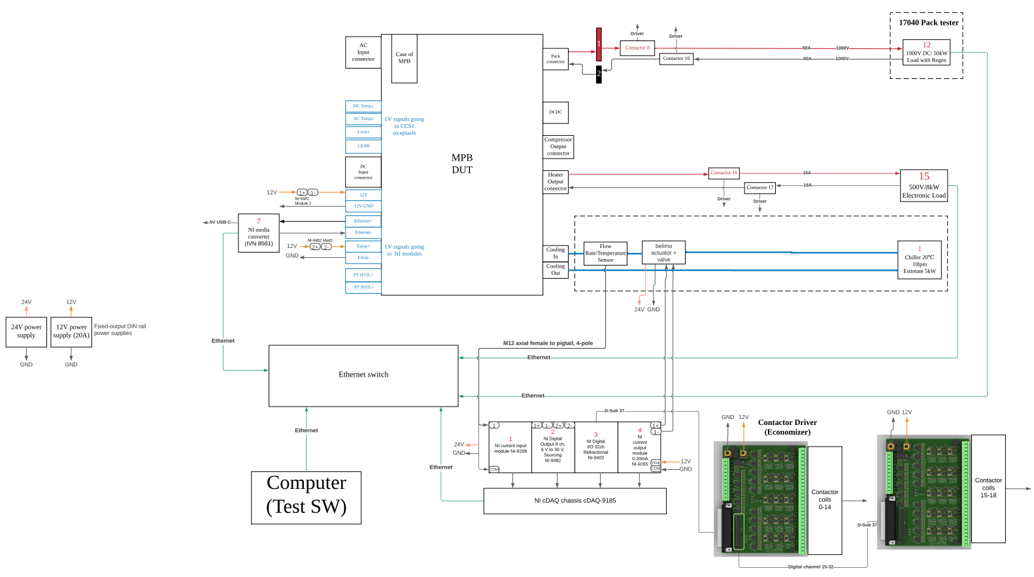

Connection and Test sequence

1. Set Regenerative Battery Pack (model 17040) to 925V/10kW as a Power Source and connect to MPB Pack connector by switching on the corresponding contactor from the LabVIEW.
2. Connect MPB Heater output to 400V/7kW with current limit 20A Electronic Load.
3. Use LabVIEW to send signal to turn on LV Harness with 12V power supply, all NI sensor detectors.
4. Use the LabVIEW to start 50kW regen/load to output 925V.
5. Use LabVIEW to send the EOL sequence number 10 and also send/receive the following signal

|  |  |  |
| --- | --- | --- |
| Haps Test | | |
| Sending Signals | Value | Unit |
| IMPB_HAPSOnOff | 1 | Enum |
| IMPB_HAPSFaultClear | 0 | Bool |
|  |  |  |
|  |  |  |
|  |  |  |
| Reading Signals | Value | Unit |
| IMPB_HAPSCurr |  | A |
| IMPB_HAPSPwr |  | was |
| IMPB_HAPSVoltgOut |  | V |
| IMPB_HAPSFltFlag |  | Bool |
| IMPB_HAPSFltCode |  | uint8 |
|  |  |  |
|  |  |  |
|  |  |  |

1. MPB will send output DC voltage, DC current and fault code to LabVIEW via Ethernet.
2. LabVIEW shall display and compare it with pre-defined threshold to indicate it pass or fail.
3. Check Pass/Fail and turn off power

MPB Automotive Ethernet Interface

All MPB communication shall be integrated to LabVIEW test program

Test Software

* LabVIEW

Test Data Requirements

|  |  |
| --- | --- |
| Test input |  |
| Test output | Pass/Fail |
| Test log | Yes |

HAPS-Compressor output

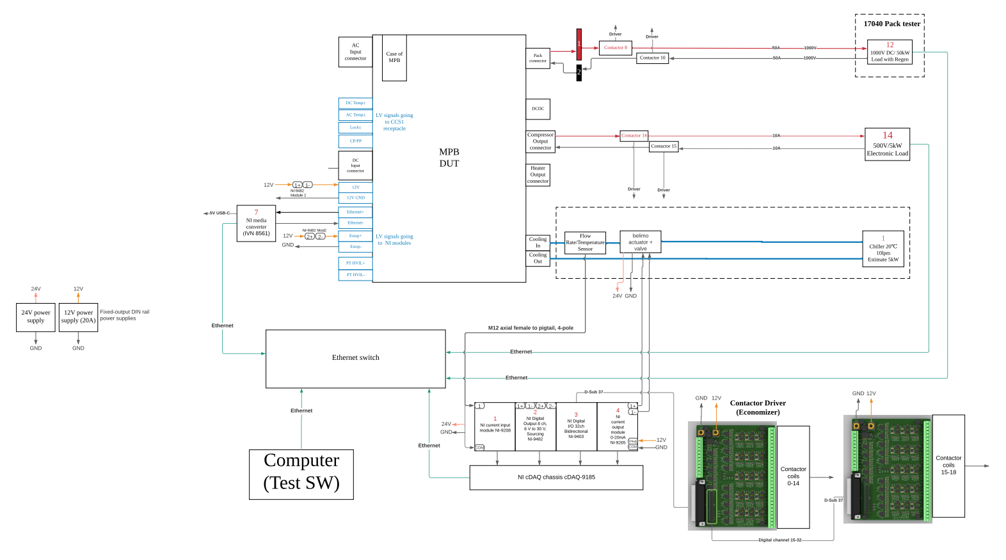

Connection and Test sequence

1. Set Regenerative Battery Pack (model 17040) to 925V/10kW as a Power Source and connect to MPB Pack connector by switching on the corresponding contactor from the LabVIEW.
2. Connect MPB Compressor output to 400V/4kW with current limit 20A Electronic Load.
3. Use LabVIEW to send signal to turn on LV Harness with 12V power supply, all NI sensor detectors.
4. Use the LabVIEW to start 550V/10kW power supply to output 550V.
5. Use LabVIEW to send the EOL sequence number 10 and also send/receive the following signal

|  |  |  |
| --- | --- | --- |
| Haps Test | | |
| Sending Signals | Value | Unit |
| IMPB_HAPSOnOff | 1 | Enum |
| IMPB_HAPSFaultClear | 0 | Bool |
|  |  |  |
|  |  |  |
|  |  |  |
| Reading Signals | Value | Unit |
| IMPB_HAPSCurr |  | A |
| IMPB_HAPSPwr |  | was |
| IMPB_HAPSVoltgOut |  | V |
| IMPB_HAPSFltFlag |  | Bool |
| IMPB_HAPSFltCode |  | uint8 |
|  |  |  |
|  |  |  |
|  |  |  |

1. MPB will send output DC voltage, DC current and fault code to LabVIEW via Ethernet.
2. LabVIEW shall display and compare it with pre-defined threshold to indicate it pass or fail.
3. Check Pass/Fail and turn off power

MPB Automotive Ethernet Interface

All MPB communication shall be integrated to LabVIEW test program

Test Software

* LabVIEW

Test Data Requirements

|  |  |
| --- | --- |
| Test input |  |
| Test output | Pass/Fail |
| Test log | Yes |

DCDC output

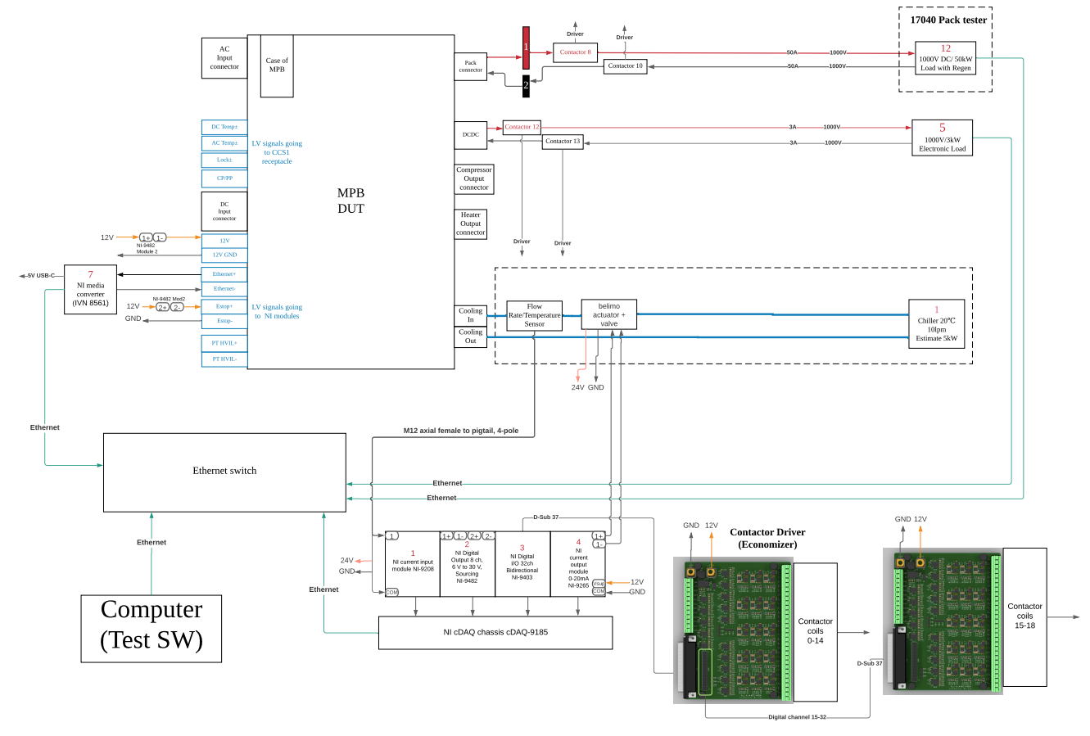

Connection and Test sequence

1. Set Regenerative Battery Pack (model 17040) to 925V/10kW as a Power Source and connect to MPB Pack connector by switching on the corresponding contactor from the LabVIEW.
2. Set Electronic Load to 925V/3kW, and Connect MPB DCDC output.
3. Use LabVIEW to send signal to turn on LV Harness with 12V power supply, all NI sensor detectors.
4. Use the LabVIEW to start 925V/10kW power supply to output 925V.
5. LabVIEW shall read the voltage and current from E-Load.
6. LabVIEW shall display and compare it with pre-defined threshold to indicate it pass or fail.
7. Check Pass/Fail and turn off power
8. Turn off the chiller to complete EOL test

MPB Automotive Ethernet Interface

All MPB communication shall be integrated to LabVIEW test program

Test Software

* LabVIEW

Test Data Requirements

|  |  |
| --- | --- |
| Test input |  |
| Test output | Pass/Fail |
| Test log | Yes |